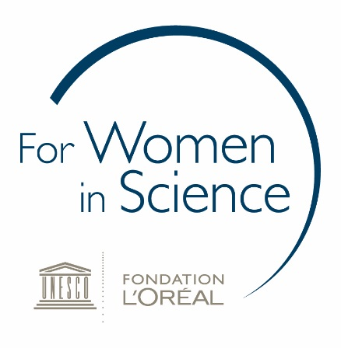
Mentee application form
Personal information
Last name: First name:

Title: Age:

Gender: Organisation/University:
(You must identify as female to apply)

Contact information
Email address:

Address: Phone number:

City: Postal code:
Education Information
University/Institute:

PhD year (2nd, 3rd, ≥4th) (Please note you must have completed at least 1 year of your candidature):

Student (full-time OR part-time):

Under which scientific discipline do you best belong (please tick box)?
- Engineering & related fields
- Medical Sciences & Health
- Information Technology
- Mathematics
- Natural & Physical Sciences
- Agriculture, Environment & related
- Architecture & Building

Briefly describe your PhD project (max. 250 words)
Include project relevance, methodology and any significant findings thus far (if applicable).
No references required.

Provide a short essay explaining why you would benefit from a mentor (max. 500 words)
Address your strengths and weaknesses and areas you wish to develop and grow. Also include any relevant ambitions or goals for your future and how a mentor could potentially facilitate your success in achieving these.

Signature:
Date:

Please save this form as a PDF and email to:
KIERA FLYNN
L'Oréal Australia
Phone +61 448 042 019
Email kiera.flynn@loreal.com

Mentee applications close Friday 10th April 5:00PM

